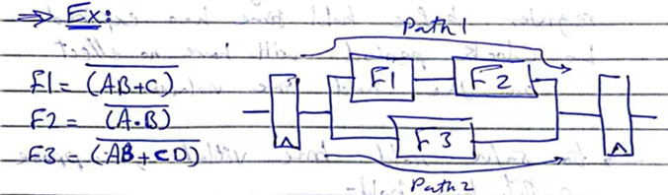
(1) Assuming $t_{cq}=t_{su}=0.69R_{o}C_{o}$, find the minimum clock period (assume registers loading is negligible).
Answer:
To know the minimum clock period, we need to identify the critical path using the worst-case delays:
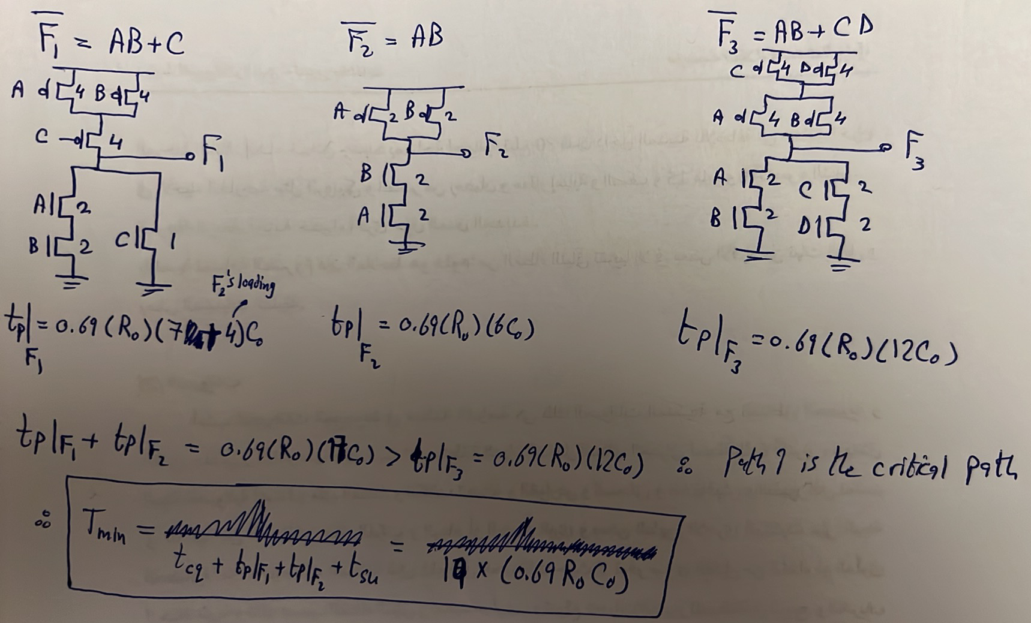
(2) Assume that the clock period can’t be more than $0.69*14R_{o}C_{o},$what type of violation do we have? Slack? How to solve it?
Answer:
$T_{min}$is $0.69*\left(19R_{o}C_{o}\right)$ while the used clock period is $0.69*14R_{o}C_{o}$. Thus, there is a setup-time violation with a negative slack of $0.69*6R_{o}C_{o}$. To solve this, break the critical path, which is path 1, as follows:
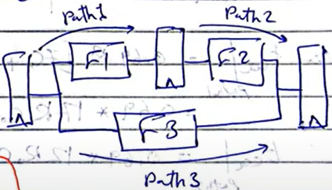
$$t_{p}{\left.​\right|}_{path 1}=0.69*\left(R_{o}\right)\left(7C_{o}\right) \left(no F2^{'}s loading anymore\right)$$
$$t_{p}{\left.​\right|}_{path 2}=0.69*\left(R_{o}\right)\left(6C_{o}\right)$$
$$t_{p}{\left.​\right|}_{path 3}=0.69*\left(R_{o}\right)\left(12C_{o}\right)$$
Thus, path 3 becomes the critical path with critical path delay of:
$t_{cq}+t_{path 3}+t_{su}=0.69R_{o}C_{o}+0.69\left(R_{o}\right)\left(12C_{o}\right)+0.69R_{o}C_{o}=0.69*{(14R}_{o}C_{o})=T_{min} ✓$
(3) What if $t_{clk}=0.69*10R_{o}C_{o}?$
Answer:
The only solution here is to somehow break path 3 and do internal pipelining if possible. If not possible, the design or clock period must be changed.
(4) Assume $t_{hold}=0.69*4.25R_{o}C_{o}$ after the situation in part (2), do we have any violations? How to solve them?
Answer:
For hold-analysis, we calculate the best-case delays:
$$t_{p}{\left.​\right|}_{F_{1},best}=t_{phl}{\left.​\right|}_{F_{1},best}=0.69\left(0.5R_{o}\right)\left(7C_{o}\right)=0.69\left(3.5R_{o}C_{o}\right)$$
$$t_{p}{\left.​\right|}_{F_{2},best}=t_{plh}{\left.​\right|}_{F_{2},best}=0.69\left(0.5R_{o}\right)\left(6C_{o}\right)=0.69\left(3R_{o}C_{o}\right)$$
$$t_{p}{\left.​\right|}_{F_{3},best}=t_{phl}{\left.​\right|}_{F_{1},best}=t_{plh}{\left.​\right|}_{F_{1},best}=0.69\left(0.5R_{o}\right)\left(7C_{o}\right)=0.69\left(3.5R_{o}C_{o}\right)$$

$$arrival time{\left.​\right|}_{path1}=t_{cq}+t_{p}{\left.​\right|}_{F_{1}}=0.69\left(4.5R_{o}C_{o}\right)$$
$$arrival time{\left.​\right|}_{path2}=t_{cq}+t_{p}{\left.​\right|}_{F_{2}}=0.69\left(4R_{o}C_{o}\right)$$
$$arrival time{\left.​\right|}_{path3}=t_{cq}+t_{p}{\left.​\right|}_{F_{3}}=0.69\left(4.5R_{o}C_{o}\right)$$
$$Required time=t_{hold}=0.69(7R_{o}C_{o})$$
Since we want $arrival time>required time→$path 2 has a hold-time violation. How to solve it? By adding two unit inverters having a delay of $0.69*{3R}_{o}C_{o}$ in path 2. However, we need to check back that this does not cause a setup violation:
$$t_{p}{\left.​\right|}_{path_{2},worst}=t_{cq}+\left(t_{p}{\left.​\right|}_{F_{2},worst}+{2*t}_{p}{\left.​\right|}_{inverter}\right)+t_{su}=0.69R_{o}C_{o}+\left[0.69*\left(R_{o}\right)\left(6C_{o}\right)+2*0.69*{3R}_{o}C_{o}\right]+0.69R_{o}C_{o}=0.69*\left(14R_{o}C_{o}\right)≤T_{clk}=0.69*\left(14R_{o}C_{o}\right) ✓$$

